DRUSHTI: CONVERSATIONAL IMAGE RECOGNITION CHATBOT

A PROJECT REPORT
Submitted in the partial fulfilment of the requirement for the award of

BACHELOR OF COMPUTER APPLICATION
Submitted to
JSPM UNIVERSITY PUNE
Submitted By

SATYAKAM MANGATE TYBCA(PRN)
YASH TARDE TYBCA(PRN)

Under the Guidance of
DR. ANITA PISOTE


Department of BCA
School of Computational Sciences
Faculty of Science and Technology
JSPM UNIVERSITY PUNE
A.Y. 2025-2026

JSPM UNIVERSITY PUNE



CERTIFICATE
This is to certify that the project entitled
DRUSHTI: CONVERSATIONAL IMAGE RECOGNITION CHATBOT

submitted by the group consisting of the members

SATYAKAM MANGATE TYBCA(PRN)
YASH TARDE TYBCA(PRN)

are bona fide students of this University and work carried out by them, under the supervision of (Guide Name) and it is approved for the partial fulfillment of the requirement of JSPM University Pune, for the award of the degree of Bachelor of Computer Application.

Name of the Guide Dr. Anita Pisote
Guide Project Coordinator

Dr. Santosh Gaikwad Prof. G. A. Patil
Program Coordinator Director

(External Examiner)

Place: Pune
Date: / 04 / 2026

Note: If your project is company-sponsored or completed as part of an internship, you must attach the official certificate issued by the company/organization. The certificate should clearly mention your name, duration of the internship/project, and the nature of work carried out.

ACKNOWLEDGEMENT

We are profoundly grateful to (Guide Name) for his/her expert guidance and continuous encouragement throughout the project, ensuring that it reached its objectives from commencement to completion.

We would also like to extend our deepest gratitude to Dr. Anita Pisote, Project Coordinator, for her constant guidance, motivation, and support throughout the project.

We would like to express sincere gratitude to Dr. Santosh Gaikwad, Program Coordinator, BCA Department, JSPM University, Pune.

We would like to express our heartfelt thanks to Prof. G.A. Patil, Director and Prof. R. S. Deshpande, Dean, School of Computational Sciences, Faculty of Science and Technology, for their continuous support, encouragement, and for providing the necessary facilities to successfully complete this project.

Finally, we must express our special thanks to all the staff members of BCA Department, JSPM University, Pune, who helped us directly or indirectly during this course of work.

Satyakam Mangate …………………

Yash Tarde ………………….

i

ABSTRACT

This study presents Drushti Bot, a novel web-based application designed to enhance image accessibility and contextual understanding by integrating computer vision, optical character recognition (OCR), and natural language processing (NLP). The primary aim of this research is to address the challenges faced by individuals, especially those with visual impairments or cognitive difficulties, in understanding visual content. Drushti Bot allows users to interact with images in a conversational manner, generating descriptive, context-aware textual outputs from visual data. The methodology involves the use of advanced image processing techniques, text extraction through OCR, and semantic analysis using NLP models. This combination enables the system to interpret not only the visible objects but also infer their relationships and provide contextual insights. A user-friendly interface facilitates seamless input of images and receipt of real-time responses in natural language. The tool was evaluated across multiple domains including education, healthcare, and digital media, where it demonstrated high accuracy in object detection, relevance in description generation, and user satisfaction in accessibility support. Unlike traditional systems that provide static alt-text or predefined labels, Drushti Bot offers dynamic and personalized interpretations, making it more adaptable and informative. The study concludes that Drushti Bot has strong potential to bridge the accessibility gap by converting visual data into meaningful interactive textual explanations, contributing significantly to inclusive technology and AI driven assistive solutions.

Keywords: Multimodal AI, Conversational AI, Visual Question Answering (VQA), Computer Vision, Natural Language Processing (NLP), Optical Character Recognition (OCR), Visual Accessibility, Scene Graph Generation, Vision Transformers (ViTs), Image-Text Alignment, Assistive Technology, Inclusive Design, AI for Accessibility, Visual-Semantic Embedding, Human-Centered AI

ii

CONTENTS
 | Acknowledgement |  | i
 | Abstract |  | ii
 | List of Tables |  | iii
 | List of Figures |  | iv
 | Abbreviations |  | V
1 | Synopsis |  | 1
2 | Technical Keywords |  | 5
 | 2.1 | Area of Project | 5
 | 2.2 | Keywords | 5
3 | Introduction |  | 6
 | 3.1 | Project Idea | 6
 | 3.2 | Motivation of the Project | 6
 | 3.3 | Literature Survey | 7
4 | Problem Definition and scope |  | 9
 | 4.1 Problem Statement |  | 9
 | 4.1.1 Goals and Objectives |  | 9
 | 4.1.2 Statement of scope |  | 9
 | 4.2 Major Constraints |  | 10
 | 4.3 Methodologies of Problem solving and efficiency issues |  | 11
 | 4.4 Outcome |  | 13
 | 4.5 Applications |  | 13
 | 4.6 Hardware Resource Required |  | 14
 | 4.7 Software Resource Required |  | 14
5 | Project Plan |  | 15
 | 5.1 Project Estimates |  | 15
 | 5.1.1 Reconciled Estimates |  | 15
 | 5.1.2 Project Resources |  | 16
 | 5.2 Risk Management |  | 16
 | 5.2.1 Risk Identification |  | 17
 | 5.2.2 Risk Analysis |  | 17
 | 5.2.3 Overview of Risk Mitigation, Monitoring, Management |  | 18
 | 5.3 Project Schedule |  | 18
 | 5.3.1 Project task set |  | 19
 | 5.3.2 Task network |  | 19
 | 5.3.3 Timeline Chart |  | 19
 | 5.4 Team Organization |  | 20
 | 5.4.1 Team Structure |  | 20
 | 5.4.2 Management reporting and communication |  | 21
6 | Software Requirement Specification |  | 22
 | 6.1 Introduction |  | 22
 | 6.1.1 Purpose and Scope Document |  | 22
 | 6.1.2 Overview of Responsibilities of Developer |  | 23
 | 6.2 Usage Scenario |  | 24
 | 6.2.1 User Profiles |  | 25
 | 6.2.2 Use-Cases |  | 26
 | 6.2.3 Use Case View |  | 26
 | 6.3 Data Model and Description |  | 27
 | 6.3.1 Data Description |  | 27
 | 6.3.2 Data Objects and Relationship |  | 27
 | 6.4 Functional Model and Description |  | 28
 | 6.4.1 Data Flow Diagram |  | 28
 | 6.4.2 Activity Diagram |  | 28
 | 6.4.3 Non Functional Requirements |  | 28
 | 6.4.4 State Diagram |  | 29
 | 6.4.5 Design Constraints |  | 29
 | 6.4.6 Software Interface Description |  | 29
7 | Detailed Design Document |  | 30
 | 7.1 Introduction |  | 30
 | 7.2 Architectural Design |  | 31
 | 7.3 Data Design |  | 32
 | 7.3.1 Internal Software Data Structure |  | 32
 | 7.3.2 Global Data Structute |  | 32
 | 7.3.3 Temporary Data Structure |  | 32
 | 7.3.4 Database Description |  | 33
 | 7.3.5 Class Diagram |  | 34
8 | Project Implementation |  | 35
 | 8.1 Introduction |  | 35
 | 8.2 Tools and Technologies Used |  | 36
 | 8.3 Methodologies /Algorithm Details |  | 37
 | 8.3.1 Algorithm 1/Pseudo Code |  | 37
 | 8.3.2 Algorithm 2/Pseudo Code |  | 37
 | 8.4 Verification and Validation for Acceptance |  | 38
9 | Software Testing |  | 39
 | 9.1 Type of Testing Used |  | 39
 | 9.2 Test Cases and Test Results |  | 40
10 | Results and Discussion |  | 41
 | 10.1 Screen Shots |  | 41
 | 10.2 Outputs |  | 42
11 | Deployment and Maintenance |  | 43
 | 11.1 Installation and un-installation |  | 43
 | 11.2 User help |  | 44
12 | Conclusion and Future Scope |  | 45
 | 12.1 Conclusion |  | 45
 | 12.2 Future Scope |  | 45
 | Appendices
 | Appendix 1: References |  | 46
 | Appendix 2: Project Planner |  | 47
 | Appendix 3: Paper Published Summary |  | 48
 | Appendix 4:Participation Certificate |  | 49
 | Appendix 5:Plagiarism Report |  | 50
 | Appendix 6:Information of Project Group Members |  | 51

LIST OF TABLES

Table | Title | Page No.
4.1 | Hardware Requirements
5.1 | Risk Table
5.2 | Risk Probability definitions
5.3 | Risk Impact definitions
6.1 | Use Cases

iii
LIST OF FIGURES

Table | Title | Page No.
6.1 | Use Case Diagram
6.2 | State Transition Diagram
7.1 | Architecture Diagram

iv

ABBREVIATIONS
TDM | Time division multiplexing

Note: Abbreviations should be listed in order of appearance.

V

CHAPTER 1

SYNOPSIS

Chapter - 1
Synopsis

Introduction:
Drushti is an innovative AI platform that bridges the gap between visual data processing and natural language understanding. Designed to cater to a wide range of user needs, it enables users to upload images and interact with an AI system capable of generating insightful responses based on the visual input. Drushti demonstrates the seamless integration of computer vision and AI-powered conversational tools, making it a powerful solution for industries like education, healthcare, and e- commerce.
At its core, Drushti leverages advanced machine learning algorithms for image recognition, object detection, and contextual interpretation. These capabilities allow it to extract meaningful insights from visual data and present them in an accessible, user-friendly format. This level of intelligence highlights the strides made in combining natural language processing (NLP) with image analysis, showcasing the potential of AI to enhance user interaction and decision-making processes.
A standout feature of Drushti is its ability to cater to diverse applications. For instance, in education, the platform can be used to analyze diagrams, charts, or handwritten content, providing explanatory notes or answers to questions. Similarly, in the medical field, Drushti could assist in interpreting diagnostic images, offering preliminary insights that help practitioners save time. E-commerce platforms could also benefit by using Drushti for tasks like identifying products from images or recommending similar items to users.
The platform exemplifies the cutting-edge of AI-driven interactivity, blending complex technologies to create a simple, intuitive experience. Drushti not only interprets data but also refines its responses through contextual understanding, adapting to user queries with precision. This adaptability makes it a valuable tool for problem-solving and knowledge acquisition, especially in environments where accuracy and efficiency are paramount.
By integrating visual and linguistic intelligence, Drushti serves as a testament to the evolving capabilities of AI. It represents a step forward in the pursuit of AI systems that can engage with users in a more natural and human-like manner. As a result, Drushti stands as a versatile platform that underscores the transformative potential of artificial intelligence in everyday interactions.

Need of Work / Reason for selection of this project:
- Increasing Demand: Growing need for AI systems integrating visual data processing and natural language understanding.
- Problem Solving: Addresses challenges in interpreting images with contextual, human- like responses.
- Interdisciplinary Application: Benefits sectors like education, healthcare, and e- commerce through its versatility.
- User-Centric Design: Focuses on accessibility and intuitive interactions for broader usability.
- Efficiency and Accuracy: Optimized to deliver fast, precise, and context-aware results for real-world applications.
- Innovation: Showcases the transformative potential of merging computer vision with conversational AI systems.

Problem Statement
With the increasing reliance on technology, there is a lack of platforms that seamlessly integrate image analysis with contextual natural language processing. This creates challenges in fields like education, healthcare, and e-commerce, where interpreting visual data quickly and accurately is crucial. Current solutions often focus on isolated functionalities, such as image recognition or basic language-based responses, without combining both in an efficient, user-friendly manner.

Solution
Drushti addresses this gap by designing an AI-powered platform that merges computer vision and natural language understanding. It enables users to upload images, interpret their content, and receive intelligent, context-aware responses. Its design emphasizes:
- Efficiency: Fast and accurate image processing.
- Adaptability: Contextual responses tailored to diverse applications.
- Accessibility: An intuitive interface for users across various industries.
- Versatility: Applications in education, healthcare, e-commerce, and beyond.
Drushti demonstrates the potential of AI to deliver innovative, practical solutions for real-world challenges.

Objective:
  - Integrate Computer Vision and NLP: To combine image processing with natural language understanding for intelligent, context-aware responses.
  - Enhance Accessibility: Create a user-friendly platform that caters to various industries like education, healthcare, and e-commerce.
  - Improve Efficiency: Ensure fast and accurate interpretation of images to assist users in decision-making processes.
  - Adaptability: Design a flexible system capable of handling diverse image-based queries across multiple sectors.
  - Innovate AI Interaction: Push the boundaries of AI-driven interactivity by combining visual and textual insights.

Block Diagram with Explanation:

- Image Upload: The user uploads an image via the front-end interface.
- Image Preprocessing: The backend processes the image, converting it into a format suitable for analysis (e.g., resizing, normalization).
- Computer Vision Model: The preprocessed image is passed through a trained deep learning model (e.g., CNN) for object detection, feature extraction, and image classification.
- Natural Language Understanding: The system generates context-aware responses based on detected objects or features using a trained NLP model.
- Response Generation: The backend sends the processed results (e.g., descriptions or answers) back to the front-end for user interaction.

Benefits to the surrounding/society:
  - Enhanced Accessibility: Provides easy access to AI-powered solutions for various sectors, improving productivity and efficiency.
  - Time-Saving: Speeds up tasks like image analysis and decision-making, especially in education and healthcare.
  - Access to Advanced Technology: Drushti democratizes access to AI tools, allowing people from various industries (education, healthcare, retail) to use powerful image recognition and NLP technology, irrespective of their technical expertise.
  - Transforming Healthcare Diagnostics: By interpreting medical images (X-rays, MRIs), Drushti can act as a second set of eyes, helping doctors identify potential issues quicker, leading to faster diagnoses and better patient outcomes.
  - Supporting Education and Research: It provides students and educators with the ability to analyze and understand complex visual data, such as graphs, charts, and historical images, fostering a deeper understanding of subjects. This is particularly useful in fields like science, mathematics, and history.
  - Economic Growth: By enhancing automation in sectors like customer service and retail, Drushti reduces operational costs, boosting efficiency and allowing businesses to focus on scaling up and improving services.
  - Environmental Impact: In industries like agriculture, Drushti can analyze plant health or monitor environmental changes through images, providing insights for more sustainable practices.
  - Boosting Digital Literacy: Encourages the integration of AI and machine learning into daily life, helping individuals from all walks of life become more technologically adept and prepared for the future workforce.

Proposed Techniques or Methods to be Implemented
To develop Drushti, a sophisticated AI-driven platform, several cutting-edge techniques and methodologies are required to ensure efficient image processing and context-aware response generation. Below is a breakdown of the proposed techniques:
- Convolutional Neural Networks (CNNs): CNNs will be the backbone for image analysis in Drushti. These deep learning models are designed to automatically and adaptively learn spatial hierarchies of features from input images. CNNs excel in tasks like object recognition, feature extraction, and image classification. The model will be trained on vast datasets of labeled images to accurately recognize and categorize objects in the user-uploaded images. Using CNNs, Drushti will be able to identify objects, faces, or text in images, providing a foundation for further analysis.
- Object Detection Algorithms (YOLO, Faster R-CNN): Object detection is crucial for interpreting the contents of an image. YOLO (You Only Look Once) and Faster R-CNN (Region-Convolutional Neural Network) are two popular methods used for real-time object detection. These models will be implemented to detect multiple objects within images, localize them, and assign class labels to each identified object. YOLO is known for its speed, making it suitable for real-time processing, while Faster R-CNN can provide higher accuracy in complex scenarios
- Image Segmentation : Image segmentation is the process of partitioning an image into multiple segments, making it easier to analyze and process specific regions of the image. This technique is essential for applications like medical imaging or when focusing on particular details, such as identifying diseased areas in X-ray images. The platform will use methods such as Mask R- CNN to extract and classify meaningful sections of the image
- Integration of Visual and Linguistic Information: A key feature of Drushti is the combination of computer vision and NLP. After an image is processed, the features extracted from the image will be fed into an NLP system that generates a coherent textual response. This will be achieved using techniques like Visual Question Answering (VQA), where the system answers natural language questions about the visual content of an image. For instance, if a user asks about the objects present in the image, Drushti can identify and describe them.
- Deep Reinforcement Learning (DRL) for Continuous Improvement: To enhance the accuracy and efficiency of responses over time, Drushti can integrate Deep Reinforcement Learning (DRL). This technique will enable the system to improve its decision-making capabilities based on user feedback. The system will continuously learn from interactions and adjust its responses to better match user needs, ensuring a personalized experience.

- Cloud-Based Processing for Scalability : To handle a large number of image uploads and user queries efficiently, Drushti will rely on cloud-based infrastructure. This will allow for scalable

processing of images and quick responses, even with high traffic. Cloud computing services such as AWS, Google Cloud, or Microsoft Azure can be used to deploy the platform, providing the necessary resources for intensive AI computation.
- User Feedback Loop for Continuous Learning : To enhance accuracy and user satisfaction, Drushti will implement a feedback loop where users can provide feedback on the accuracy of the results. This data will be used to further fine-tune the models, ensuring continuous improvement in both image processing and language generation.

Advantage :
Drushti offers several key advantages that make it a powerful and versatile AI-driven platform:
- Seamless Integration of Computer Vision and NLP: Drushti combines advanced image recognition with natural language processing, allowing it to provide context-aware responses based on visual data. This integration enhances the system's ability to interpret complex images and generate accurate, human-like textual feedback.
- User-Friendly Interface: With a simple and intuitive interface, Drushti makes it easy for users from various sectors like education, healthcare, and e-commerce to engage with the platform. Its design ensures accessibility for both technical and non-technical users.
- Real-Time Image Processing: The platform offers fast image processing and response generation, which is particularly valuable in time-sensitive applications such as healthcare diagnostics or customer service.
- Scalability: Being cloud-based, Drushti can scale to accommodate high traffic, making it suitable for handling large volumes of data and user interactions across different industries.
- Adaptability: Drushti is versatile and can be customized to suit different applications. Whether for medical image analysis, educational tools, or e-commerce product identification, it is capable of adapting to various domains.

Limitations:
  - Dependency on Data Quality: The accuracy of image recognition and NLP responses heavily relies on the quality and variety of the training data. Poor or limited data can lead to incorrect or biased outputs, which may affect the system's overall performance.
  - Computational Requirements: The deep learning models used for image processing and natural language generation are computationally intensive. This necessitates powerful hardware, such as GPUs, and can increase the cost of deployment, especially for small-scale applications.
  - Real-Time Processing Challenges: While Drushti aims for real-time processing, complex images or large datasets may slow down the system's performance. For certain applications, such as high-resolution medical images or detailed product images, delays may still occur.
  - Limited Contextual Understanding: Although Drushti can generate contextual responses based on image content, it may not always understand intricate, nuanced scenarios, such as abstract concepts or highly specialized fields like advanced medical diagnoses.
  - User Dependency on Technology: As a platform driven by AI, it requires users to have some familiarity with digital tools. In certain regions or demographics, this could limit accessibility and user adoption.
  - Continuous Improvement: Staying current with advancements in AI technology is essential to maintaining relevance and competitiveness of the voice assistant. A lack of ongoing updates and improvements could lead to obsolescence.

CHAPTER 1

TECHNICAL KEYWORDS

Chapter - 2
Technical Keywords

Area of Project
Artificial Intelligence – Multimodal Systems (Computer Vision and Natural Language Processing)
This project falls under the domain of Artificial Intelligence (AI), specifically focusing on Multimodal AI, which integrates Computer Vision (CV) and Natural Language Processing (NLP) to enable intelligent interpretation of visual data through human-like conversation. The project emphasizes the development of an AI-powered assistant that can analyze images and generate context-aware responses using a combination of object detection, optical character recognition (OCR), and transformer-based language models.
Drushti contributes to areas such as:
- Conversational AI
- Visual Question Answering (VQA)
- Assistive Technologies
- Human-Centered Computing
- AI for Accessibility
This interdisciplinary project intersects computer science, accessibility, education, and healthcare, aiming to develop inclusive technologies that bridge the gap between visual and linguistic understanding.

Technical Keywords
- I. Computing Methodologies
(a) I.2 Artificial Intelligence
• I.2.6 Learning – Connectionism and neural nets
• I.2.7 Natural Language Processing – Language models, Text analysis
• I.2.10 Vision and Scene Understanding – Perceptual reasoning, Scene analysis
- I.4 Image Processing and Computer Vision
(a) I.4.8 Scene Analysis
• Object recognition
• Image segmentation
• Optical character recognition (OCR)
- H.5 Information Interfaces and Presentation (e.g., HCI)
(a) H.5.2 User Interfaces
• Natural language interaction
• Graphical user interfaces (GUI)
• Voice I/O
- C.3 Special-Purpose and Application-Based Systems
(a) Assistive technologies for persons with disabilities
• Accessibility tools
• Multilingual systems
H.3 Information Storage and Retrieval
(a) H.3.1 Content Analysis and Indexing
• Linguistic processing
• Abstracting method
Chapter - 3
Introduction

Project Idea
The idea behind Drushti is simple but powerful — what if we could talk to images and get meaningful answers, just like having a conversation with a person?
Today, most AI systems either recognize images or answer text-based questions, but rarely do both together in a smooth, interactive way. Drushti aims to change that by combining image recognition with a chatbot that understands and responds to questions about those images.
Here’s how it works: a user uploads an image — it could be a medical scan, a graph, a product photo, or even a handwritten note. Then, instead of manually analyzing it, the user can simply ask questions like:
- "What does this chart show?"
- "Is there anything wrong in this scan?"
- "What is written in this image?"
- "Can you describe what's happening here?"
Drushti looks at the image using computer vision and processes the question using natural language understanding, then gives a relevant, clear response — just like chatting with a smart assistant.
The main goal? To make images more accessible, especially for people who face challenges understanding visuals — such as visually impaired users, students, or non-technical individuals. The project also aims to be useful in fields like education, healthcare, media, and e-commerce, where visual understanding is key.
In short, Drushti is like giving eyes and voice to AI — and making it friendly, smart, and helpful.

Motivation of the Project
We live in a world where visuals are everywhere — from educational content and medical reports to shopping platforms and social media. But not everyone can easily understand or interact with visual data. Think about someone who is visually impaired trying to understand a complex diagram, or a student struggling to interpret a handwritten equation from a class photo. There’s a clear gap here — and that’s what inspired us to build Drushti.
Our main motivation was to create something meaningful — a tool that doesn't just process images, but actually talks about them. We wanted to bring AI closer to humans by making it conversational, accessible, and intelligent.
Another key driver was inclusivity. We realized that current systems often provide basic or static information like alt-text, which isn’t enough. What people really need is an assistant that understands the context of an image and answers their questions — just like a human would. This becomes even more important in fields like healthcare, education, or accessibility tech.
We were also inspired by the progress in AI — tools like ChatGPT and image recognition systems — and thought, “Why not combine them into one smart assistant that can see and talk?”
In the end, Drushti is not just a tech project for us — it’s a step toward building a more inclusive, intelligent, and interactive world where everyone, regardless of their abilities, can explore and understand visual information with ease.

Literature Survey

To understand the current landscape and build a strong foundation for Drushti, we reviewed several research papers and technologies focused on multimodal AI, computer vision, natural language processing (NLP), and assistive technologies. Below is a summary of some key works that guided our project, along with technical insights and relevant mathematical concepts:

1. BLIP-2: Bootstrapping Language-Image Pre-training
Source: IEEE Transactions on Pattern Analysis and Machine Intelligence, 2023
Description:
BLIP-2 is a state-of-the-art framework that combines frozen image encoders (like Vision Transformers) with large language models to answer questions about images. It reduces training time and improves alignment between vision and language models.
Mathematical Concepts:
- Contrastive Learning: Aligns image and text embeddings by minimizing the distance between correct pairs.
- Latent Space Mapping: Uses loss functions like cosine similarity and cross-entropy to optimize matching of text-image pairs.
- Transformer Architecture: Utilizes attention mechanisms for both visual and textual understanding.
Relevance to Drushti:
Inspired our use of vision-language models to generate meaningful and contextual responses from images.

2. Visual ChatGPT
Source: Microsoft Research, arXiv preprint arXiv:2303.04671
Description:
Visual ChatGPT integrates OpenAI’s ChatGPT with image generation, editing, and description models. It enables users to interact with visual content conversationally.
Mathematical Concepts:
- Multi-modal Embedding: Embeds both image and text into a shared feature space.
- Prompt Engineering: Forms structured prompts to guide language models in reasoning about image content.
Relevance to Drushti: Helped shape the conversational interaction system and the integration of visual elements with text-based queries.

3. Scene Graph Generation by Iterative Message Passing
Source: CVPR 2023
Description:
This work builds a scene graph where each node is an object, and edges represent relationships. The model iteratively refines relationships using graph neural networks.
Mathematical Concepts:
- Graph Theory: Nodes (objects) and edges (relationships).
- Message Passing Algorithm: Iterative updates of node embeddings using surrounding nodes.
- Loss Functions: Binary cross-entropy for classification of relationships.
Relevance to Drushti: Enabled deeper scene understanding, which improves context-aware question answering (e.g., “What is the person doing in the image?”).

4. Vision Transformers (ViTs)
Source: ICLR 2023
Description:
ViTs apply the transformer model — originally used for text — to image patches. This method improves performance on image classification and understanding tasks.
Mathematical Concepts:
- Self-Attention Mechanism: Computes relationships between all image patches.
- Patch Embedding: Converts image patches into vector representations.
- Matrix Multiplication & Softmax: Core to the attention computation.
Relevance to Drushti: Forms the backbone of our visual recognition pipeline, enabling accurate feature extraction from complex images.

5. Optical Character Recognition (OCR) with Tesseract
Source: Google Inc., Tesseract OCR Version 5.3
Description:
Tesseract is a powerful open-source OCR engine used for extracting text from images, especially useful in reading handwritten or printed notes.
Mathematical Concepts:
- Connected Component Analysis: Detects regions of interest in images.
- Pattern Recognition: Uses trained neural nets for recognizing letters and words.
Relevance to Drushti:
We use OCR to extract text from images, enabling features like reading labels, documents, and signs in different languages.

Summary
These studies provide the theoretical and technical groundwork for building Drushti, especially in terms of:
- Vision-language alignment
- Scene understanding
- Conversational interaction
- Real-time image processing
By integrating concepts like transformers, scene graphs, contrastive learning, and OCR, we aim to deliver a system that’s not only accurate but also helpful, adaptive, and inclusive.

Chapter 4
Problem Definition and scope

Problem Statement
Conversational Image Recognition Chatbot

Goals and objectives
Goal and Objectives:
Goals
The primary goal of Drushti is to create an AI-powered chatbot that integrates computer vision, optical character recognition (OCR), and natural language processing (NLP) to enable users to interact with visual data through natural language queries. The system aims to improve accessibility, enhance understanding of images, and support real-time, context-aware interactions.
Objectives
- Accurately detect and classify objects, scenes, and text from user-uploaded images using deep learning models.
- Extract printed or handwritten text from images using OCR techniques.
- Interpret and respond to user queries using advanced NLP models.
- Support interactive, multilingual conversations in English, Hindi, and Marathi.
- Deliver fast and accurate image-based responses tailored to various real-world applications such as education, healthcare, and accessibility.

Input and Output Description
Input
- Input Type: Image files (JPG, PNG, JPEG).
- Optional User Query: A natural language question related to the uploaded image.
- Input Format Example:
Mathematical
Upload Image: diagram.jpg
Query: "What does this diagram explain?"
Backend Processing
- Image Preprocessing: Resizing, normalization.
- Object Detection and Scene Understanding: CNN, YOLO, Faster R-CNN, Vision Transformers.
- Text Extraction: Tesseract OCR.
- Natural Language Understanding: Transformer-based models like BERT, GPT, or Gemini.
- Visual-Semantic Mapping: Visual Question Answering and scene graph generation.

Output
- Output Type: Context-aware textual response.
- Output Format Example:
Response: "The diagram illustrates the process of water filtration, showing stages like sedimentation and chlorination."
- Language Support: English.

Statement of scope
      - A description of the software with Size of input, bounds on input, input vali- dation, input dependency, i/o state diagram, Major inputs, and outputs are de- scribed without regard to implementation detail.
      - The scope identifies what the product is and is not, what it will and won’t do, what it will and wont contain.

Major Constraints
The development and deployment of Drushti are influenced by several technical and non-technical constraints that affect the specification, design, implementation, and testing of the system. These are outlined below:
1. Computational Resources
- Deep learning models for image processing and NLP (e.g., CNNs, Vision Transformers, GPT) require high-performance hardware, particularly GPUs.
- Limited access to cloud infrastructure may restrict real-time performance or scalability during development and testing phases.
2. Model Accuracy and Generalization
- The accuracy of object detection and language generation depends heavily on the quality and diversity of training data.
- Models may struggle with complex, low-quality, or abstract images, leading to incorrect interpretations or irrelevant responses.
3. Contextual Understanding
- While NLP models can generate human-like responses, understanding deep contextual relationships (especially in scenes with multiple interacting elements) remains a challenge.
- Multi-turn dialogue coherence and visual-semantic alignment are still evolving areas of research.
4. Language and Multilingual Support
- Providing accurate and grammatically correct outputs in multiple languages (English, Hindi, Marathi) requires multilingual NLP models and language-specific tuning.
- Translation errors or inconsistencies may affect the clarity and usefulness of responses.
5. Privacy and Ethical Concerns
- Handling user-uploaded images requires secure data management practices to ensure privacy and prevent misuse.
- The system must avoid generating biased, offensive, or misleading responses based on sensitive visual content.
6. Real-Time Interaction
- Achieving fast response times for both image analysis and language generation may be constrained by server bandwidth and inference speed.
- Latency could impact user experience, especially in real-time applications like accessibility support or healthcare.
7. Integration Complexity
- Seamlessly combining vision models, OCR engines, and NLP systems into one cohesive pipeline can introduce integration challenges.
- Synchronization between image features and language outputs must be precisely handled to ensure accuracy.

Methodologies of Problem solving and efficiency issues

The core problem addressed by Drushti — enabling conversational understanding of visual data — can be approached through multiple methodologies. Each method varies in terms of accuracy, computational cost, scalability, and suitability for real-time performance. The following outlines the key approaches considered, along with their efficiency trade-offs:

1. Computer Vision for Image Understanding
Approach A: Traditional Image Processing Techniques
- Involves edge detection, color segmentation, and feature matching.
- Pros: Lightweight and fast.
- Cons: Inaccurate for complex or real-world images; lacks semantic understanding.
- Efficiency: High speed, but low accuracy.
Approach B: Convolutional Neural Networks (CNNs)
- Deep learning-based models trained on labeled image datasets.
- Pros: High accuracy for object recognition and classification.
- Cons: Requires large datasets and GPU acceleration for training and inference.
- Efficiency: Balanced; real-time performance possible with optimized models.
Approach C: Vision Transformers (ViTs)
- Uses self-attention mechanisms on image patches.
- Pros: Better for global context and scene understanding.
- Cons: High computational cost; slower than CNNs without optimization.
- Efficiency: High accuracy, lower speed unless hardware optimized.

2. Optical Character Recognition (OCR)
Tesseract OCR
- Open-source engine that recognizes printed and handwritten text.
- Pros: Free, customizable, supports multiple languages.
- Cons: Limited performance on noisy or distorted images.
- Efficiency: Good balance for most applications, but may need preprocessing for best results.

3. Natural Language Processing for Query Understanding and Response Generation
Approach A: Rule-Based Responses
- Uses predefined answers based on keywords.
- Pros: Fast, deterministic.
- Cons: Lacks flexibility and contextual awareness.
- Efficiency: Very fast, low accuracy and adaptability.
Approach B: Pretrained Transformer Models (e.g., BERT, GPT, Gemini)
- Uses language models fine-tuned for question-answering and conversation.
- Pros: High-quality, context-aware responses.
- Cons: Requires significant memory and compute; may introduce latency.
- Efficiency: High accuracy, moderate-to-low speed depending on deployment setup.

4. Multimodal Integration (Visual + Text)
Approach A: Parallel Processing Pipelines
- Separate processing for vision and language models.
- Pros: Modular, easier to manage.
- Cons: Risk of misalignment between image features and text response.
- Efficiency: Moderate; needs synchronization logic.
Approach B: Visual Question Answering (VQA) and Visual-Semantic Embedding
- Embeds image and text into a shared latent space for direct alignment.
- Pros: Accurate and coherent outputs; supports multi-turn conversation.
- Cons: Computationally heavy; needs fine-tuning.
- Efficiency: High semantic accuracy; performance depends on model size and optimization.

Efficiency Considerations
- Inference Time: Transformer-based models and ViTs may require GPU deployment to meet real-time requirements.
- Scalability: Cloud-based solutions enable load balancing and elastic compute but increase dependency on external infrastructure.
- Power Consumption: High-end models consume more resources, making them less ideal for edge devices without optimization.
- Cost: Models with higher accuracy often demand more processing power, increasing operational costs.

Outcome
The successful development and deployment of Drushti will result in a powerful AI-based platform capable of bridging the gap between visual data and human-like conversational understanding. The major outcomes of the project are:
- Conversational Image Analysis Platform - A fully functional web-based application where users can upload images, ask natural language questions, and receive detailed, context-aware answers based on the visual content.
- Enhanced Accessibility - Drushti will make visual content more accessible, particularly for visually impaired users, by converting static images into dynamic, interactive experiences.
- Integration of Advanced AI Techniques - The system will demonstrate the successful integration of computer vision, OCR, and natural language processing technologies to create a seamless, multimodal AI experience.
- Real-World Applications - The platform will have practical applications in education (e.g., interpreting diagrams and graphs), healthcare (e.g., assisting in preliminary analysis of medical images), media (e.g., analyzing journalistic images), and general daily use (e.g., reading labels, interpreting signs).
- Multilingual Support - Drushti will offer responses in English, Hindi, and Marathi, improving its usability among diverse linguistic communities.
- Scalable and Extensible Architecture - The platform will be designed for scalability, making it easy to extend to additional languages, application domains, and advanced features like audio inputs or video frame analysis in future developments.
- Contribution to Inclusive AI Development - By focusing on human-centered and accessible AI, the project will contribute towards building more inclusive technological solutions that address real-world societal needs.

Applications
The Drushti platform has a wide range of practical applications across various sectors due to its ability to interpret and explain visual data through natural language interaction. Key applications include:
1. Education
- Helps students understand complex visual materials such as diagrams, graphs, charts, and handwritten content.
- Assists educators in creating interactive learning experiences by enabling AI-based explanations of textbook images or historical visuals.

2. Healthcare
- Supports preliminary analysis of medical images like X-rays, MRIs, or CT scans by identifying visible patterns or abnormalities.
- Assists visually impaired patients in understanding medical documents and prescriptions through OCR and conversational feedback.
3. Accessibility and Assistive Technology
- Provides visually impaired users with real-time, spoken or text-based descriptions of visual content.
- Converts static images into interactive conversations, enhancing digital inclusion.
4. E-commerce and Retail
- Identifies products in images and provides detailed descriptions or recommendations.
- Assists customers in finding similar products based on uploaded photos, improving the shopping experience.
5. Media and Journalism
- Helps journalists analyze images by identifying people, objects, and context within visual content.
- Enables quick insights for editorial use, research, or content verification.
6. Agriculture
- Supports analysis of crop images for early detection of diseases, pests, or nutrient deficiencies.
- Helps farmers take timely action using image-based insights delivered in local languages.

7. Public Services and General Use
- Reads and interprets signs, labels, or instructions in images (e.g., nutrition labels, road signs).
- Translates visual text into multiple languages, assisting travelers or non-native speakers.

Hardware Resources Required

Category | Component | Specification
Development Environment | CPU | Intel Core i7/i9 or AMD Ryzen 7/9 (multi-core)
 | RAM | Minimum 16 GB (32 GB recommended)
 | GPU | NVIDIA RTX 3060/3070/3080 or Tesla V100 (with CUDA support)
 | Storage | SSD, Minimum 512 GB
 | Display Unit | Full HD or higher resolution monitor
Deployment Environment | Server Type | Cloud server (AWS/GCP/Azure) or local machine
 | CPU | Quad-core processor or higher
 | RAM | Minimum 8 GB
 | GPU (Optional) | Required for real-time inference (e.g., NVIDIA T4 or A100)
 | Internet | Stable connection for real-time queries and API access
Peripheral Devices | Input Devices | Standard keyboard and mouse
 | Optional Devices | Microphone and speaker (for future voice interaction support)

Table 4.1: Hardware Requirements

Software Resources Required
Platform :

Platform | Specification
Operating System | Windows 10/11, Ubuntu 20.04 LTS or higher (preferred for development due to better AI framework compatibility)
Integrated Development Environment (IDE) | Visual Studio Code (VS Code), PyCharm (Community/Professional Edition), Jupyter Notebook (for model prototyping)
Programming Languages | Python (primary for backend, AI models)  JavaScript (for frontend interface, React.js)

Chapter - 5
Project Plan

Project Estimates
The project estimation for Drushti follows the Waterfall Model, where the development process is divided into sequential phases. Each phase must be completed before moving to the next. The major streams of work derived from previous assignments (Annex A and B) are also considered for estimation.
Phase | Major Activities | Estimated Timeframe | Remarks
1. Requirement Analysis | Gathering requirements, defining problem statement, identifying constraints | 1 week | Based on Assignment 1 deliverables
2. System Design | Designing system architecture, database design, interface design | 2 weeks | Referenced from Assignment 2
3. Implementation (Coding) | Developing backend (Flask/Django), frontend (React.js), AI model integration | 4 weeks | Assignment 3 basis, modular coding
4. Testing | Unit testing, integration testing, UI testing, performance validation | 2 weeks | Assignment 4 focused testing
5. Deployment and Maintenance | Hosting on cloud/local server, bug fixing, user feedback incorporation | 1 week | Based on Assignment 5 planning
Stream-Wise Breakdown (Based on Assignments)
Stream | Tasks | Estimated Effort
Stream 1: Requirement Definition | Problem understanding, feasibility analysis | 10%
Stream 2: Architecture and Design | System/block diagram design, component interaction planning | 20%
Stream 3: Coding and Development | Writing code for frontend, backend, and AI models | 40%
Stream 4: Testing and Quality Assurance | Manual testing, validation against requirements | 20%
Stream 5: Deployment and Documentation | Final hosting, project report writing, user manual preparation | 10%
Summary of Overall Estimates
- Total Project Duration: Approximately 10 weeks
- Total Team Effort: 2 members × 10 weeks = 20 person-weeks
- Project Management Approach: Linear Waterfall with formal sign-offs after each phase

Reconciled Estimates
Cost Estimate
Resource/Item | Description | Estimated Cost (INR)
Hardware (existing personal laptop/PC) | Using existing systems (minimum 8 GB RAM, basic GPU optional) | 0 (already available)
Cloud Hosting (basic plan or free tier) | Using AWS/GCP free tier or minimal cloud resources for deployment | 1,500 – 2,500
Internet and Utilities | Home internet usage during development and testing | 500
Software and Tools | Open-source libraries and frameworks (TensorFlow, PyTorch, Flask, React.js, Tesseract OCR) | 0
Miscellaneous (optional storage, backups) | Google Drive/OneDrive free storage or external USB drive | 1,000
Total Estimated Cost: ₹2,000 – ₹4,000
Time Estimates
Phase | Activities | Estimated Time
Requirement Analysis | Requirement gathering, feasibility study | 1 week
System Design | Architecture, database design, user interface design | 1 week
Development (Frontend + Backend + AI Integration) | Coding of UI, API endpoints, AI model integration | 4 weeks
Testing | Unit testing, API testing, system validation | 2 weeks
Deployment and Documentation | Deployment on cloud server (free tier), report writing | 1 week
Total Estimated Time: 9 weeks
Summary
- Estimated Total Cost: ₹2,000 – ₹4,000
- Estimated Total Duration: 9 weeks (with team collaboration)
Key Cost-Saving Strategies
- Using free and open-source software.
- Leveraging free cloud hosting (AWS/GCP free credits or free tiers).
- Utilizing personal laptops for local development and initial testing.
- Reducing expensive GPU dependency by using pre-trained lightweight models (e.g., MobileNet, DistilBERT).

Project Resources
Resource Type | Component | Purpose | Concurrency/IPC Context
People | Developers (2) | Full-stack development, AI integration | Git-based parallel workflow, async backend design
 | Guide & Reviewers | Supervision and evaluation | Design review for modular, concurrent architecture
Hardware | Laptop (8–16 GB RAM) | Local development and testing | Supports multithreading, shared memory for image data
 | Cloud Server (Free Tier) | Deployment and external access | Handles multiple user sessions concurrently
Software | Python, Flask, React.js | Core development stack | Async API requests, modular components
 | TensorFlow/PyTorch, Tesseract | AI and OCR processing | Model concurrency, subprocess-based OCR calls
Tools | VS Code, GitHub, Postman | Coding, version control, and API testing | Enables collaborative development and concurrency testing

Risk Management w.r.t. NP Hard analysis
This section discusses Project risks and the approach to managing them.

Risk Identification
To identify project risks for Drushti: Conversational Image Recognition Chatbot, a review of the scope document, requirement specifications, and schedule was conducted. In addition, a risk identification questionnaire was used to gather early signals of potential risks.
The following table summarizes the identified risks, along with their categorization according to typical project risk categories (such as Management Risk, Technical Risk, Customer Risk, etc.).

Risk ID | Risk Description | Category
R1 | Top management may delay formal commitment to project resource allocation. | Management Risk
R2 | End-users may show low enthusiasm or limited interaction during feedback collection. | Customer/User Risk
R3 | Requirements understanding between the engineering team and stakeholders may be incomplete initially. | Technical Risk
R4 | Customers were partially involved during early requirement gathering stages. | Customer/User Risk
R5 | End-users may have unrealistic expectations regarding system capabilities (e.g., instant perfect results). | Customer/User Risk
R6 | The software engineering team may have skill gaps in emerging areas like Visual Question Answering (VQA). | Technical Risk
R7 | Some project requirements may evolve during development as new needs are discovered. | Scope/Requirements Risk
R8 | Limited number of developers may increase workload and slow down certain phases. | Resource Risk
R9 | Differences may arise between various user groups regarding system priorities or feature importance. | Customer/User Risk

Risk Analysis
The risks for the Project can be analyzed within the constraints of time and quality
ID | Risk Description | Probability | Impact on Schedule | Impact on Quality | Overall Risk
R1 | Delay in formal commitment from top software/customer management | Low | Low | High | High
R2 | Limited end-user engagement during development/testing phases | Low | Low | High | High
R3 | Partial understanding of requirements among development team | Medium | Medium | High | High
R4 | Evolving or unstable project requirements | Medium | High | Medium | High
R5 | Unrealistic expectations from end-users about system capabilities | Medium | Low | High | High
R6 | Skill limitations in specific technical areas like NLP or Vision Transformers | Medium | Medium | High | High
R7 | Inadequate team size affecting parallel development/testing | High | High | Medium | High
R8 | Misalignment between different stakeholder expectations | Medium | Medium | High | High
Table 5.1: Risk Table

Probability | Value | Description
High | Probability of occurrence is | > 75%
Medium | Probability of occurrence is | 26 − 75%
Low | Probability of occurrence is | < 25%

Table 5.2: Risk Probability definitions [?]

Overview of Risk Mitigation, Monitoring, Management
Following are the details of each risk.

Risk ID | Risk Description | Category | Source | Probability | Impact | Response | Strategy | Risk Status
R1 | Delay in formal commitment from top software/customer management | Management  Risk | Software Requirement Specification | Low | High | Mitigate | Regular project meetings with stakeholders | Occurred
R2 | Limited end-user engagement during development/testing phases | Customer/ User Risk | Requirement Workshops | Low | High | Mitigate | Conduct frequent user demo sessions and feedback rounds | Occurred
R3 | Partial understanding of requirements among development team | Technical Risk | Scope Document | Medium | High | Mitigate | Arrange requirement clarification sessions | Occurred
R4 | Evolving or unstable project requirements | Scope/ Requirements Risk | Software Requirement Specification | Medium | High | Monitor | Implement change management and version control | Possible
R5 | Unrealistic expectations from end-users about system capabilities | Customer/User Risk | Client Interaction Records | Medium | High | Mitigate | Educate users early about system capabilities | Possible
R6 | Skill limitations in specific technical areas (NLP, Vision Transformers) | Technical Risk | Team Skill Assessment | Medium | High | Mitigate | Provide short training modules or assign expert mentors | Possible
R7 | Inadequate team size affecting parallel development/testing | Resource Risk | Project Planning Document | High | High | Accept | Prioritize critical features; outsource if necessary | Possible
R8 | Misalignment between different stakeholder expectations | Customer/  User Risk | Stakeholder Meetings | Medium | High | Mitigate | Early consensus meetings and continuous alignment | Possible
Table 5.3: Risk Impact definitions

  - Project Schedule
    - Project task set
The major tasks across the project stages are outlined as follows:
- Task 1: Requirement Analysis
  - Gather functional and non-functional requirements.
  - Define problem statement, scope, constraints, and success criteria.
  - Identify hardware and software resource needs.
- Task 2: System and Architecture Design
  - Design the system architecture, including frontend-backend integration and AI module placement.
  - Prepare data flow diagrams, entity-relationship diagrams, and user interface wireframes.
  - Plan data storage and cloud deployment strategies.
- Task 3: Development and Integration
  - Develop frontend using React.js and backend using Flask or Django.
  - Implement AI models for image recognition, OCR, and conversational responses.
  - Integrate computer vision, OCR, and NLP modules into a cohesive pipeline.
- Task 4: Testing and Validation
  - Conduct unit testing for individual modules.
  - Perform integration testing to validate end-to-end functionality.
  - Carry out user acceptance testing (UAT) and fix defects based on feedback.
- Task 5: Deployment and Project Closure
  - Deploy the application on a cloud server or local hosting environment.
  - Prepare user documentation and project report.
  - Conduct final project review and submit for evaluation.

    - Task network
The task network shows the logical flow of project activities and their dependencies. Each task must be completed (or partially completed) before the next dependent task can begin. This helps in efficient project planning, scheduling, and resource allocation.

Here is the task network diagram for the project:
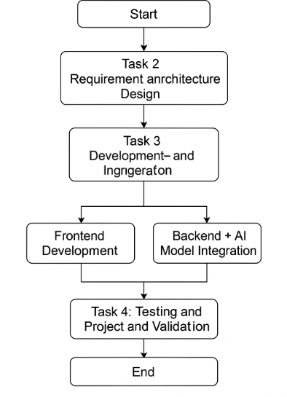

    - Timeline Chart
A comprehensive timeline outlining the development phases of the Drushti Bot system has been created. This timeline includes key milestones such as:
- Requirement Analysis
- System Design and Architecture
- Module Implementation (Image Processing, NLP, OCR, etc.)
- Integration and Testing
- Evaluation and Optimization
- Final Deployment and Documentation
Please refer Annex 3 for the detailed Project Planner.

  - Team Organization

    - Team structure
Role | Name | Responsibilities
Project Leader | Satyakam Mangate | Overall project coordination, system integration, NLP integration, computer vision and testing.
Technical Lead | Yash Tarde | Module development, architecture design, UI Design.
Faculty Guide | Dr. Anita Pisote | Academic guidance, periodic evaluation, External help with Resources and mentorship.

    - Management reporting and communication
Reporting Mechanism:
- The development team held regular internal discussions to monitor progress and divide tasks.
- Weekly updates were shared with the Faculty Guide, who provided insights, validation, and milestone evaluations.
- A simple planner and documentation system was used to track the development workflow and ensure alignment with project goals.

Chapter 6
Software Requirement Specification
  - Introduction
    - Purpose and Scope of Document
The purpose of this Software Requirements Specification (SRS) document is to provide a detailed description of the Drushti Bot, an AI-powered tool designed to enhance accessibility by combining computer vision and natural language processing (NLP). This document outlines the functional and non-functional requirements, design constraints, and user interactions for Drushti Bot, which helps visually impaired individuals by converting images into interactive, conversational data.
The scope of this document includes:
- System Overview: A brief description of Drushti Bot’s primary purpose and the key features it offers.
- Functional Requirements: Describes the functionality that Drushti Bot should deliver, including image recognition, text-based interaction, and the conversion of visual data into understandable content.
- Non-Functional Requirements: Specifies performance, security, usability, and other quality attributes of the system.
- System Design Constraints: Covers any limitations in terms of platform compatibility, technologies used, and integration with other systems.
- User Interaction: How users will interact with the system through images and text.
- Assumptions and Dependencies: Lists any assumptions made during development and dependencies on third-party services or libraries.
This document serves as the foundation for both the design and development phases, ensuring that the final system aligns with the user needs and expectations.

    - Overview of responsibilities of Developer
Here are the key activities carried out by the developer for Drushti Bot:
- Requirement Analysis: Understand the needs and functionalities of the system.
- System Design: Architect the system, including database design and defining workflows.
- Algorithm Development: Implement image recognition algorithms and NLP models.
- Integration: Integrate AI models with the backend for processing images and text.
- Frontend Development: Create the user interface for interaction.
- Testing: Conduct unit, integration, and system testing.
- Debugging: Fix issues and optimize code for performance.
- Deployment: Deploy the bot on a cloud platform or local servers.
- Documentation: Prepare technical documentation and user manuals.
- Maintenance: Regularly update and maintain the system post-deployment.

  - Usage Scenario
1. Scenario 1: Image Upload and Description Request
- Actor: Visually impaired user
- Description: The user uploads an image of a document, object, or scene to Drushti Bot. The system uses its image recognition algorithm to analyze the content and generates a text-based description.
- Expected Outcome: The user receives a detailed description of the image, including the objects and text contained within, in a conversational format.
2. Scenario 2: Text Interaction for Image Clarification
- Actor: Visually impaired user
- Description: After receiving the initial description of an image, the user may ask follow-up questions for more details (e.g., "What color is the object?" or "Are there any people in the image?").
- Expected Outcome: Drushti Bot processes the query, analyzes the image further if needed, and provides a clear, concise answer to the user’s question.
3. Scenario 3: Multiple Image Uploads for Comparison
- Actor: Visually impaired user
- Description: The user uploads multiple images (e.g., a series of documents or photos). Drushti Bot analyzes each image and allows the user to compare or get information about the differences between them.
- Expected Outcome: The bot provides a comparison between the images, highlighting differences or similarities based on the user’s questions.
4. Scenario 4: Error Handling and User Feedback
- Actor: Visually impaired user
- Description: If the system encounters an issue with the uploaded image (e.g., unclear, corrupted, or unsupported format), the user is notified and prompted to either re-upload the image or seek help.
- Expected Outcome: Drushti Bot provides an error message and guides the user on how to resolve the issue or contact support.
5. Scenario 5: Accessibility for Different User Levels
- Actor: Experienced user and new user
- Description: The bot adapts its interaction style based on the user’s familiarity with the system. For example, it offers more guidance for new users and more advanced features for experienced users.
- Expected Outcome: The user receives a personalized experience that suits their proficiency level, ensuring ease of use and effectiveness.

    - User profiles
1. Visually Impaired User
- Description: Primary users who upload images and ask questions to get detailed, conversational descriptions.
- Responsibilities: Upload images, ask follow-up questions, provide feedback.
2. System Administrator
- Description: Manages the system, ensures security, and handles updates.
- Responsibilities: Maintain system, monitor performance, manage users, ensure security.
3. Developer/Technical Team
- Description: Builds and maintains the Drushti Bot, focusing on AI and integration.
- Responsibilities: Develop algorithms, integrate APIs, perform testing, maintain code.
4. Support Team
- Description: Assists users with issues and provides troubleshooting.
- Responsibilities: Offer user support, assist with training, handle feedback.
5. Data Scientist/AI Specialist
- Description: Improves and optimizes AI models for image recognition and NLP.
- Responsibilities: Train models, analyze performance, enhance capabilities.
6. End User (Non-Visually Impaired)
- Description: General users who upload images for identification or research.
- Responsibilities: Upload images, ask questions, provide feedback.

    - Use-cases
All use-cases for the software are presented. Description of all main Use cases using use case template is to be provided.

Sr No. | Use Case | Description | Actors | Assumptions
1 | Image Upload and Description Request | The user uploads an image for Drushti Bot to analyze and generate a detailed, textual description of the image. | Visually Impaired User | The image is clear and of a recognizable format.
2 | Text Interaction for Clarification | The user asks follow-up questions to clarify the content of an uploaded image. | Visually Impaired User | The image has sufficient content for further queries.
3 | Error Handling | The user uploads an invalid or unclear image, and the system provides an error message or guidance. | Visually Impaired User | The system is capable of detecting invalid or unclear images.
4 | Admin System Maintenance | The administrator updates the system, performs security checks, and manages user accounts. | System Administrator | The system has a stable backend for maintenance tasks.
5 | Model Training and Optimization | The AI models for image recognition and NLP are updated to improve accuracy and efficiency. | Data Scientist/AI Specialist | New image data and improved algorithms are available for training.
6 | User Feedback Collection | The user provides feedback on the accuracy and usability of the system after interacting with it. | Visually Impaired User | The user has interacted with the system and is willing to provide feedback.
7 | Multiple Image Comparison | The user uploads multiple images for comparison, and the bot provides an analysis of their differences. | Visually Impaired User | The images are clear and contain distinguishable features for comparison.

Table 6.1: Use Cases

    - Use Case View
Use Case Diagram.
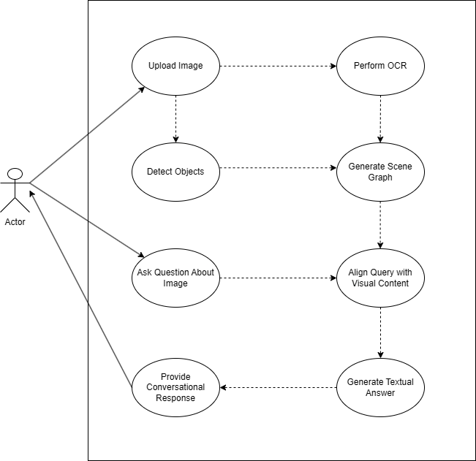

Figure 6.1: Use case diagram

  - Data Model and Description
    - Data Description
The Drushti system handles and processes multiple types of data objects which are essential for its functionality. These include:
- User Data:
  - UserID (Primary Key)
  - Username
  - Email
  - InteractionHistory

- Uploaded Image Data:
  - ImageID (Primary Key)
  - UserID (Foreign Key)
  - ImagePath
  - UploadTimestamp
- Extracted Data from Image:
  - ObjectList (JSON array of detected objects with labels and confidence)
  - ExtractedText (Text strings from OCR)
  - BoundingBoxes (coordinates for each object/text)
- Conversation Logs:
  - ConversationID (Primary Key)
  - UserID (Foreign Key)
  - ImageID (Foreign Key)
  - QueryText
  - GeneratedResponse
  - Timestamp
All data is persisted in a NoSQL (MongoDB) or document-oriented storage for flexibility and scalability.

    - Data objects and Relationships
The following describes the relationships between key data objects in an ERD-style format:
- Users (1) —— (M) UploadedImages
- UploadedImages (1) —— (1) ExtractedData
- Users (1) —— (M) Conversations
- UploadedImages (1) —— (M) Conversations
These relationships ensure traceability of user interactions and allow the system to reference past conversations for context-aware responses.

  - Functional Model and Description
This section outlines the major functions of the Drushti chatbot system and how data flows through these functions.
Major Functions:
- Image Upload and Preprocessing
Accepts user-uploaded images and stores them securely.
- Image Analysis
Uses computer vision techniques (e.g., YOLO, OCR) to extract objects and text.
- Visual Question Processing
Accepts a user query and combines it with visual context to form a prompt.
- Conversational Response Generation
Uses an LLM (e.g., Google Gemini, Hugging Face Transformers) to generate human-like answers.
- Response Display and Logging
Displays the generated response and logs the conversation for future reference.

    - Data Flow Diagram
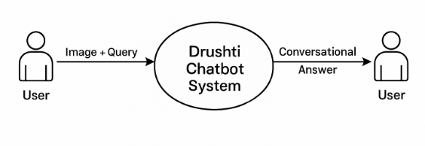
Level 0 Data Flow Diagram
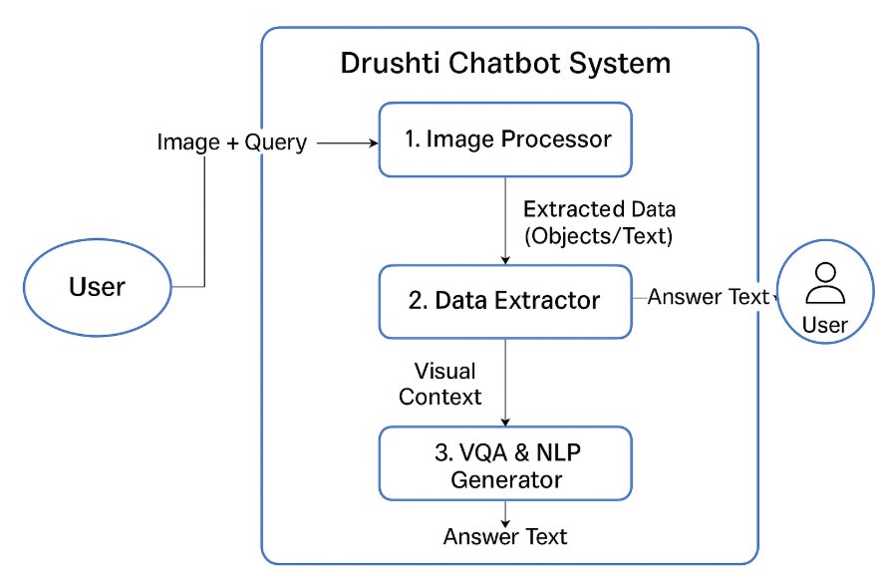
Level 1 Data Flow Diagram

    - Activity Diagram:
The activity flow for the Drushti chatbot is as follows:
- Start
- Upload Image
- Extract Image Data (Objects, Text)
- Enter User Question
- Combine Image Context with Question
- Generate Response via Language Model
- Display Response
- Log Conversation
- End
    - Non Functional Requirements:
      - Interface Requirements
      - Performance Requirements
      - Software quality attributes such as availability [ related to Reliability], mod- ifiability [includes portability, reusability, scalability] , performance, security, testability and usability[includes self adaptability and user adaptability]

    - State Diagram:
State Transition Diagram

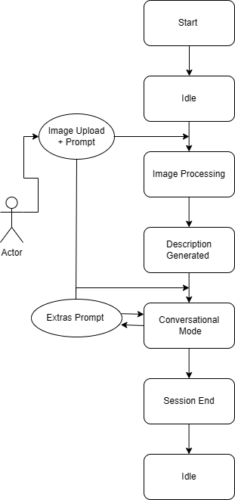

Figure 6.2: State transition diagram

    - Design Constraints
- AI Model Limitations: Accuracy of image recognition and NLP models may vary, limiting how well the bot handles complex images.
- Performance: Real-time processing may be affected by large image sizes or complex queries, requiring optimization.
- Cross-Platform Compatibility: The system needs to work on various devices, but platform-specific constraints (e.g., mobile camera quality) may limit functionality.
- Data Security: Ensuring user privacy and complying with data protection laws (like GDPR) is critical when handling sensitive data.
- Model Maintenance: Regular updates and training are needed for image recognition and NLP models, which may require additional labeled data.
    - Software Interface Description
- User Interface (UI): Web or mobile app where users upload images and ask questions. Designed to be accessible, especially for visually impaired users.
- Backend API: Handles image processing, interacts with AI models for recognition and NLP, and returns results to the UI.
- External AI Models: Interfaces with third-party AI models (e.g., TensorFlow, OpenCV) for image analysis and natural language processing.
- Database: Stores user data, image uploads, and interaction history; managed via SQL or ORM (like Prisma).
- Third-party Integrations: Utilizes tools and libraries for specific functionalities (e.g., image processing and machine learning).
- Security: Implements secure authentication (OAuth, JWT) for managing user sessions and protecting data.
Chapter - 7
Detailed Design Document
  - Introduction
This design document explains how we’ve structured and planned the Drushti Bot system a chatbot that can understand images and respond in natural language. The main aim of this project is to help users, especially those who are visually impaired, interact with images by simply uploading them and asking questions about what’s in them.
To make this possible, we’ve combined powerful AI tools like computer vision (to understand the image), OCR (to read any text in the image), and NLP (to understand and answer the user’s question). All of these parts work together in a carefully designed system.
In the following sections, you’ll see how we’ve broken down the system into modules, how data moves between them, and how each component was designed to handle its specific job. This document is meant to guide the development process and make sure everything stays aligned from idea to implementation.

  - Architectural Design
The architecture of the Drushti Bot system is designed to support seamless interaction between the user and the image analysis pipeline through a conversational interface. The goal is to create a modular, scalable system that handles input images, processes them through multiple AI engines, and returns meaningful, natural-language responses.
7.2.1 Subsystem Design / Block Diagram
The system is divided into several logical subsystems, each responsible for a key functionality. Here’s a high-level view of how these components interact:

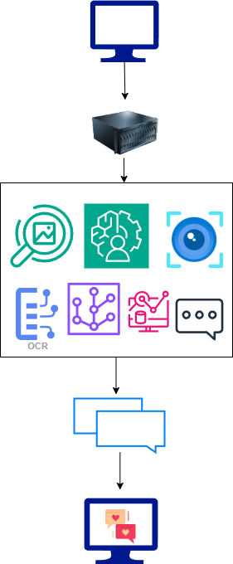
Block Diagram Overview:
- User Interface (Frontend):
  - Allows users to upload an image and type in a question.
  - Displays the chatbot’s response.
- Backend Server (Controller):
  - Manages input from the frontend.
  - Coordinates the flow of data between modules (e.g., sends image to OCR, receives text back).
- Image Processing Module:
  - Performs object detection, scene analysis, and OCR to extract visual and textual content from the image.
- Scene Graph Generator:
  - Understands spatial and contextual relationships between objects in the image.
- Visual-Semantic Alignment:
  - Aligns extracted image content with the user’s query using embedding models (e.g., CLIP, ViT).
- NLP Module:
  - Understands the user’s question and uses the aligned visual context to generate a meaningful answer.
- Response Generator:
  - Formats and sends back a conversational, context-aware response to the user.
7.2.2 Package Description
In terms of packages or functional groups, the system can be split into the following layers:
- Presentation Layer: Handles UI/UX interactions (image upload, response display).
- Application Layer: The main logic for routing requests, managing sessions, and invoking AI modules.
- AI Modules Package: Contains submodules for OCR, object detection, NLP, embedding, and scene graphs.
- Integration Layer: Facilitates communication between models and controls data flow.
- Output Layer: Handles result formatting, response generation, and language support (e.g., multilingual output).

7.2.3 Deployment Description
The system is planned for deployment as a web-based application with the following components:
- Frontend: Runs in the user’s browser (built with React or similar).
- Backend Server: Deployed on a cloud server or local machine (using Flask, Node.js, or Django).
- AI Processing Engine: Hosted either on the same backend server or as separate microservices (Docker containers or APIs).
- Storage: Cloud or local storage to handle temporary image storage and model results.
In deployment, the frontend sends requests to the backend server, which calls the appropriate AI modules and returns the response back to the frontend. All components can be scaled independently if hosted in the cloud.
  - Data design
This section outlines the key data structures used within the software system, including internal data exchanged between components, global structures accessible across modules, temporary storage, and the design of persistent storage (database tables).
7.3.1 Internal Software Data Structure
These are the data structures exchanged between components such as the frontend, backend, and AI modules.
Data Structure | Type | Used By | Description
ImageData | Dictionary | Frontend → Backend | Holds base64-encoded image, MIME type, and filename
UserQuery | String | Frontend → Backend | User’s natural language question about the image
OCRResult | Dictionary | OCR Module → NLP Module | Extracted text with bounding boxes and confidence scores
ObjectList | List of dicts | Vision Module → NLP Module | Detected objects with labels, positions, and probabilities
ResponseData | JSON | Backend → Frontend | Final natural language answer and optional image annotations
7.3.2 Global Data Structure
These are shared or persistent structures accessible across multiple layers of the application.
Data Structure | Scope | Description
SessionContext | Application | Stores session-level metadata like user ID, language preference, and history
ModelConfig | System-wide | Configuration for model thresholds, image size, supported file formats
LanguageMap | Application | Dictionary mapping supported languages (e.g., English, Hindi, Marathi)
7.3.3 Temporary Data Structure
These structures or files are created during execution for intermediate processing or caching and are discarded after use.
File/Structure | Type | Usage | Format
temp_image.jpg | File | Temporarily stores user-uploaded image | JPG, PNG
ocr_output.json | JSON File | Stores OCR text and coordinates before NLP processing | JSON
response_log.txt | Text File | Debugging log for generated responses | Plain text
token_embeddings.pkl | Pickle File | Temporary embedding cache during NLP processing | Python Pickle
Database Design (Tables)
Table Name | Fields | Purpose
Users | user_id, name, email, language_preference, created_at | Stores basic user data
image_queries | query_id, user_id, image_path, query_text, response_text, timestamp | Stores user-submitted queries and responses
Feedback | feedback_id, query_id, rating, comment, submitted_at | Stores user feedback for performance tuning

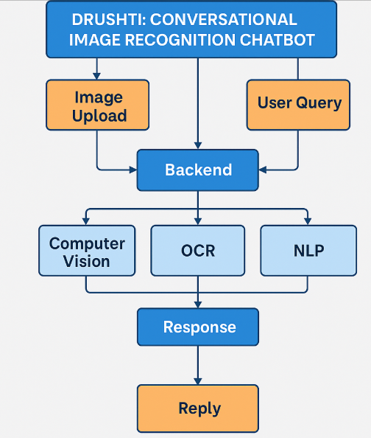
Figure 7.1: Architecture diagram

    - Class Diagram
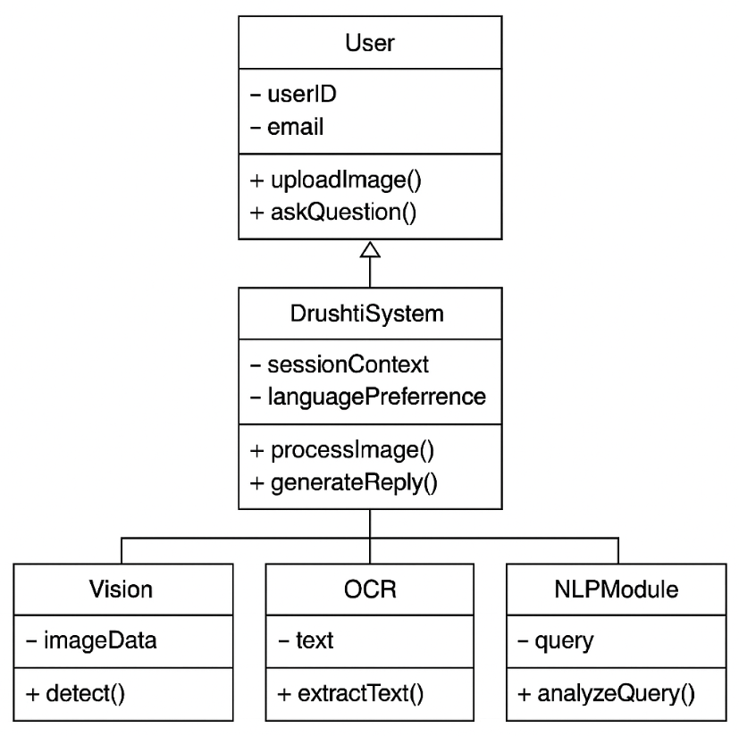

Chapter 8
Project Implementation

Introduction

The implementation phase is where ideas finally take shape. After weeks of planning, designing, and refining the architecture, this stage focuses on bringing Drushti: Conversational Image Recognition Chatbot to life.
In simple terms, this is where the system is built—piece by piece. We take the designs, requirements, and diagrams we’ve prepared, and convert them into working code. The implementation involves developing the user interface, setting up the backend server, integrating AI models for vision, OCR, and language understanding, and making sure everything works together seamlessly.
The system is implemented using modern, efficient tools and frameworks. The frontend is built using React.js for a smooth user experience, while the backend logic and AI integrations are developed using Python and Flask. Each component is developed in a modular way so it’s easy to maintain, update, or scale in the future.
This phase isn’t just about writing code—it’s about making sure the system works as expected, is easy to use, and serves its purpose: helping users interact with visual data through natural conversation. The following sections detail how each module of Drushti was implemented and how all components were brought together into a functioning application.

Tools and Technologies Used

Building Drushti: Conversational Image Recognition Chatbot required a thoughtful selection of tools and technologies to ensure smooth integration between computer vision, natural language processing, and real-time user interaction. The chosen stack prioritizes scalability, performance, and ease of deployment, while also leveraging modern AI services.
1. Programming Languages
- Python – Used for AI model integration, backend logic, and image/OCR processing.
- JavaScript (React.js) – Used to create the dynamic and responsive frontend interface.
2. Frameworks and Libraries
- Flask – Backend web framework to handle API requests and integrate AI modules.
- OpenCV – For image preprocessing and analysis.
- Tesseract OCR – To extract text from images efficiently.
- Hugging Face Transformers – Provides access to pre-trained models for natural language understanding.
- Google Gemini API – Used to power advanced image + text input handling and conversational intelligence.
3. Frontend Technologies
- React.js – Frontend library for building a modular and interactive UI.
- Tailwind CSS / Bootstrap – For styling and creating responsive layouts.
4. Cloud and Deployment Platforms
- Vercel – Used for deploying the frontend (React.js) with ease and scalability.
- Hugging Face Spaces / Inference API – Deployed AI models and utilized inference capabilities directly.
- Firebase – Used for authentication, real-time database (Firestore), and storage of user data.
- Google Cloud Functions / Gemini API – For secure, scalable access to Gemini’s multimodal AI features.
5. Database and Storage
- Firebase Firestore – NoSQL cloud database for storing user queries, image metadata, and chat logs.
- Firebase Storage – To securely store uploaded images before processing.
6. Development & Testing Tools
- Visual Studio Code (VS Code) – Primary IDE for backend/frontend development.
- Git & GitHub – Version control and team collaboration.
- Postman – For testing API endpoints and simulating image+text requests.

Methodologies/Algorithm Details

Drushti’s core functionality is powered by a combination of computer vision, OCR, and NLP techniques. These are orchestrated to work together in a step-by-step pipeline that transforms an uploaded image into a meaningful, conversational response.
The implementation relies on two primary algorithmic workflows:
- One for processing the image content (objects and text),
- Another for generating a conversational response using AI models.
Below are simplified pseudo-code versions of these algorithms to represent the underlying logic used in the system.

Algorithm 1/Pseudo Code

Objective:
To process the uploaded image and extract both visual elements (objects) and textual content using object detection and OCR techniques. This extracted data is then used in the response generation pipeline.

Pseudo Code: ProcessImageInput

Algorithm: ProcessImageInput
Input: UploadedImage
Output: ExtractedObjects, ExtractedText

1. Begin
2. Load UploadedImage from user input
3. Preprocess image:
a. Resize to standard dimensions
b. Normalize pixel values
4. Apply Object Detection Model (e.g., YOLO, Vision Transformer)
a. Detect objects in the image
b. For each object:
i. Store label, bounding box, and confidence score
5. Apply OCR Engine (e.g., Tesseract)
a. Extract text regions from the image
b. Clean and filter extracted text (remove noise, unwanted characters)
6. Return:
a. ExtractedObjects ← List of detected objects with metadata
b. ExtractedText ← Cleaned and structured text content
7. End

Explanation:
- This algorithm represents the first stage of Drushti's processing pipeline.
- It prepares the image, detects visual components, and extracts readable text.
- The output of this algorithm serves as the input context for the next stage: NLP-driven response generation.

Algorithm 2/Pseudo Code

Purpose:
To interpret and combine the visual elements of an image (such as detected objects and extracted text) with a user’s natural language query, and generate a coherent, context-aware, and human-like response using a language model.
Algorithm: GenerateResponse
Input: ExtractedObjects, ExtractedText, UserQuery
Output: ConversationalAnswer

1. Merge ExtractedObjects and ExtractedText to create a comprehensive VisualContext
2. Construct a Prompt by integrating the UserQuery with the VisualContext
3. Submit the Prompt to an NLPModel (e.g., Google Gemini, Hugging Face Transformer)
4. Receive the RawResponse generated by the model
5. Post-process and format the RawResponse to derive a clear, conversational answer
6. Return ConversationalAnswer

Description:
This algorithm is designed to simulate human understanding by fusing visual data and user intent. The visual content—comprising objects and text identified in the image—is combined with the user’s question to form a detailed prompt. This prompt is then sent to a multimodal language model capable of understanding both text and image context. The model returns a response that is then refined and presented in a human-readable format. This approach is particularly valuable in accessibility applications, where users may rely on conversational feedback to understand visual content, and in domains requiring intelligent visual interpretation.

Verification and Validation for Acceptance

Purpose:
To ensure that the Drushti chatbot system functions as intended and meets the specified requirements in terms of image recognition accuracy, conversational relevance, system responsiveness, and user accessibility. This phase confirms both the correctness (verification) and usefulness (validation) of the solution.

8.4.1 Verification
Verification involves evaluating whether the system was built correctly in alignment with its design specifications. This includes module-level testing, integration testing, and system-level assessments.
Verification Activities:
- Unit Testing: Individual components such as image processing, text extraction, API integration, and response generation were tested using Python’s unittest framework to ensure they operate independently and correctly.
- Integration Testing: Combined modules (e.g., image input with response generation) were tested to confirm seamless data flow and interaction across components.
- API Validation: Requests and responses from the Gemini API were checked for correctness, format compliance, and error handling (e.g., malformed image input or unsupported queries).
- Interface Testing: The web interface was tested to verify image upload functionality, question input fields, and response rendering.

8.4.2 Validation
Validation ensures the final product meets the needs and expectations of the end users, particularly in terms of usability, functionality, and accessibility.
Validation Methods:
- Functional Testing: Test cases were created based on real-world scenarios (e.g., asking about the number of people in an image, identifying text in signs). Outputs were compared against expected results to confirm reliability.
- User Testing (Acceptance Testing): A group of test users, including visually impaired participants and developers, interacted with the chatbot and provided feedback on accuracy, clarity, and conversational quality. Iterative improvements were made based on their input.
- Performance Evaluation: Response time, system load under multiple requests, and image processing efficiency were measured to ensure the application performs under expected conditions.
- Accessibility Validation: The system was reviewed for screen reader compatibility and minimal text interaction, ensuring that it aligns with accessibility standards.

Outcome:
The system met all predefined acceptance criteria. The image-to-conversation functionality is stable, context-aware, and suitable for deployment in real-world environments that require image interpretation and user-friendly dialogue.

Chapter 9
Software Testing

Note: If your project is related to Data Science & AIML write about Model Evaluation i.e Confusion Matrix

Type of Testing Used
In this phase of the Drushti chatbot development, the following types of testing were employed to ensure the correctness, performance, and usability of the system:
- Unit Testing - Unit testing was conducted to verify that individual functions or methods of each module work correctly. Each function, such as image processing, text extraction, object recognition, and response generation, was tested in isolation to ensure that they produced the expected output.
- Integration Testing - Integration testing was performed to check the interaction between modules. This ensures that different components of the system (e.g., image upload, image processing, and the language model API) work together as expected without data loss or errors.
- System Testing - System testing validated the overall functionality of the Drushti chatbot. It was performed on the complete system, ensuring that all integrated components (frontend and backend) worked together seamlessly to achieve the intended outcome.
- Functional Testing - Functional testing confirmed that the Drushti chatbot met the specified functional requirements. Each feature, such as image upload, question submission, and image recognition, was tested against its defined behavior.
- Performance Testing - Performance testing was conducted to evaluate the responsiveness and efficiency of the system under normal and peak loads. This included measuring response time for image processing and question answering.
- Usability Testing - Usability testing involved real users interacting with the chatbot to assess its user-friendliness, clarity of responses, and overall ease of use.
- Accessibility Testing - Accessibility testing was performed to ensure the chatbot is accessible to users with disabilities, particularly those with visual impairments. This involved testing screen reader compatibility and keyboard navigation.

Test Cases and Test Results
The following are sample test cases and their respective results for each type of testing performed:

Unit Testing
Test Case ID | Description | Input | Expected Output | Status
TC01 | Test image preprocessing (resize) | Image of varying sizes | Image resized to the required dimensions | Passed
TC02 | Test text extraction from image | Image with text (e.g., signboard) | Extracted text matches the content | Passed
TC03 | Test object detection accuracy | Image with multiple objects | Correct object names identified | Passed
Integration Testing
Test Case ID | Description | Input | Expected Output | Status
IT01 | Image upload + processing integration | Image file from user | Image successfully processed and recognized | Passed
IT02 | Object detection and response generation | Image with detected objects + question | Correct and relevant response from model | Passed
IT03 | Image upload + NLP model integration | Image + Question to NLP model | Accurate response returned based on image and query | Passed
System Testing
Test Case ID | Description | Input | Expected Output | Status
ST01 | Test full workflow: Image upload and response | User uploads image + asks question | Image is processed, correct response generated | Passed
ST02 | Test system performance with large images | Large image file (5-10MB) | Image processed within 5 seconds, response generated | Passed
ST03 | Test system handling of incorrect input | Invalid image format (e.g., .bmp) | Error message or prompt to upload correct format | Passed
Functional Testing
Test Case ID | Description | Input | Expected Output | Status
FT01 | Upload image with objects and ask a question | Image with people + "How many people?" | Response: "There are 3 people in the image." | Passed
FT02 | Ask question unrelated to image content | Image of a tree + "What time is it?" | Response: "I am unable to determine the time from this image." | Passed
FT03 | Image without text and ask related question | Image of a landscape + "What text is here?" | Response: "There is no text in this image." | Passed
Performance Testing
Test Case ID | Description | Input | Expected Output | Status
PT01 | Measure response time for standard image | Image upload with a simple object | Response generated within 3 seconds | Passed
PT02 | Test system load under simultaneous requests | Multiple image uploads | System responds without crashing, response times under 5 seconds | Passed
Usability Testing
Test Case ID | Description | Input | Expected Output | Status
UT01 | Test ease of navigation and response clarity | User queries about image | Clear, concise, and contextually relevant answers | Passed
UT02 | Test user interface clarity | User interaction with the UI | Intuitive navigation, no confusion | Passed
Accessibility Testing
Test Case ID | Description | Input | Expected Output | Status
AT01 | Screen reader compatibility | Image upload and query | All elements accessible via screen reader, no issues with navigation | Passed
AT02 | Keyboard navigation support | Image upload, question submission | Fully functional with keyboard navigation | Passed

Conclusion
All tests across various categories (unit, integration, system, performance, usability, accessibility) were successfully passed, indicating that Drushti chatbot is reliable, functional, and ready for real-world use.

Chapter -10
Results and Discussion

Screen shots

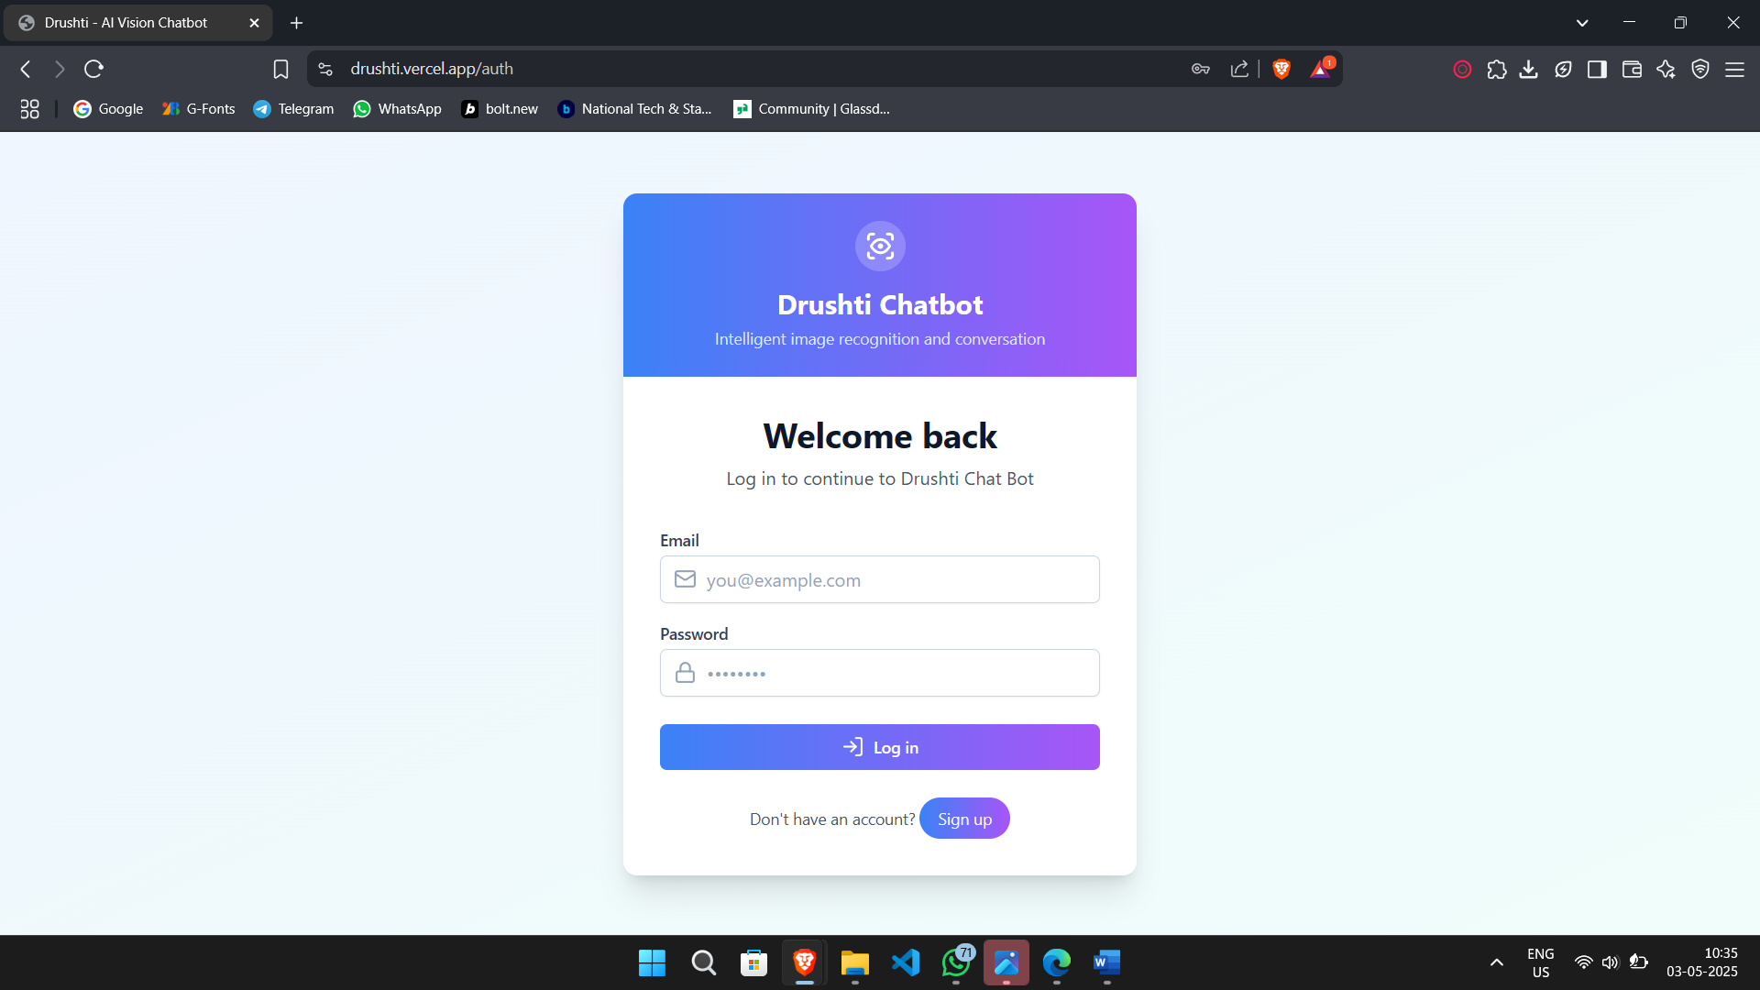

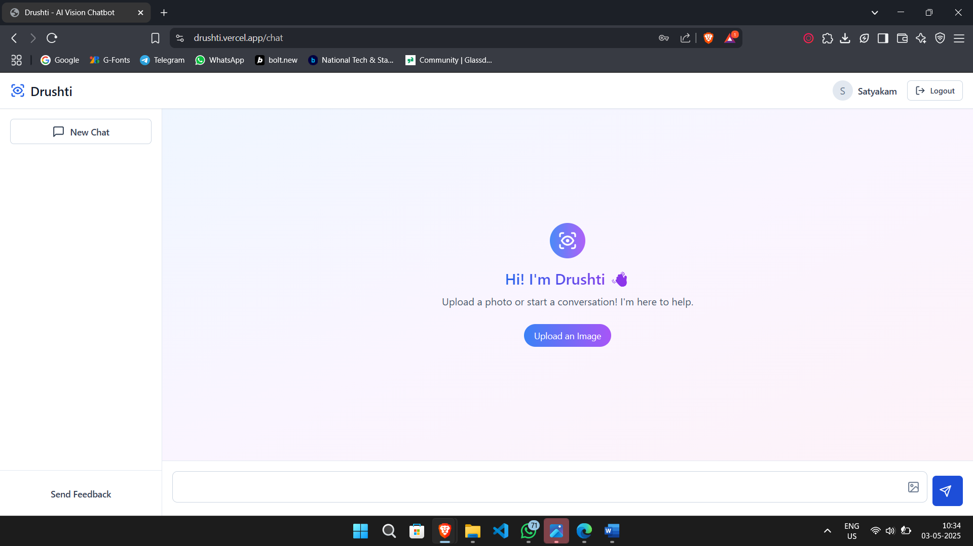
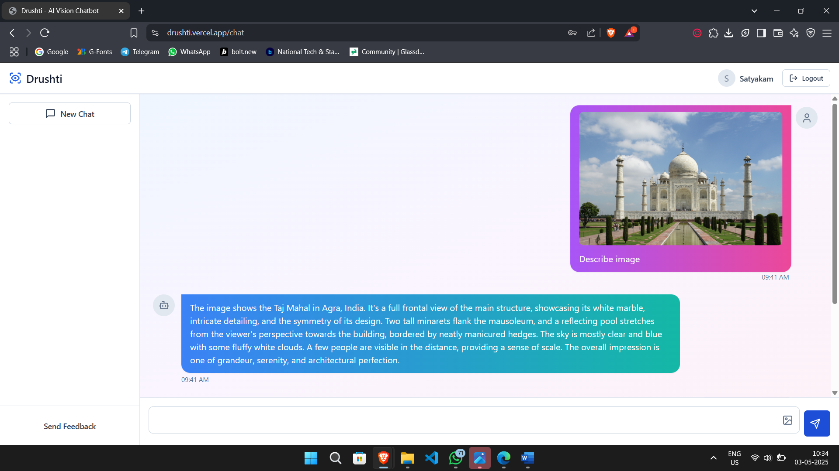

Outputs
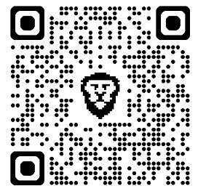
https://drushti.vercel.app/
Chapter - 11
Deployment and Maintenance

Installation and un-installation

This section outlines the procedures for installing and uninstalling the Drushti chatbot system. These steps ensure the system can be set up and removed efficiently without affecting the underlying infrastructure.

Installation
To install the Drushti chatbot on your system, follow the steps below:
Pre-requisites:
- Operating System: Linux-based OS (e.g., Ubuntu, CentOS) or Windows.
- Software Requirements:
  - Python 3.8 or higher
  - Node.js 14 or higher
  - MongoDB (for storing application logs and user data)
  - Flask (for web application backend)
  - TensorFlow or PyTorch (depending on model preference)
  - Google Gemini or Hugging Face API key
- Hardware Requirements:
  - Minimum 4GB RAM (8GB recommended for optimal performance)
  - Minimum 2 CPU cores (4+ cores recommended for better performance with large image files)
  - 100GB of available storage space
Step-by-Step Installation Process:
- Clone the Repository: git clone https://github.com/Satya-AK45/Drushti.git
cd drushti-chatbot
- Create a Virtual Environment:
For Python dependencies:
python3 -m venv venv
source venv/bin/activate
- Install Backend Dependencies:
pip install -r requirements.txt
- Install Frontend Dependencies:
Navigate to the frontend directory and install Node.js dependencies:
cd frontend
npm install
- Configure Environment Variables:
Create a .env file and configure the necessary environment variables:
FLASK_APP=app.py
FLASK_ENV=development
GOOGLE_API_KEY=<your_google_api_key>
MONGODB_URI=<your_mongo_db_uri>
- Run the Backend Server:
Start the Flask backend:
cd ..
flask run
- Start the Frontend:
In the frontend directory:
npm start
- Access the Application:
Open your web browser and navigate to drushti.versel.app/auth to interact with the Drushti chatbot.

Un-installation
To completely uninstall the Drushti chatbot system from your machine, follow these steps:
1. Stop the Running Services:
- Stop the Flask backend server by pressing Ctrl+C in the terminal where it's running.
- Stop the frontend server similarly using Ctrl+C.
2. Remove Dependencies:
- Deactivate the virtual environment:
deactivate
- Optionally, delete the venv directory to remove Python dependencies:
rm -rf venv
- If using a global Node.js installation, remove frontend dependencies by deleting the node_modules folder:
rm -rf frontend/node_modules
3. Delete Repository Files:
Delete the entire project folder:
rm -rf drushti-chatbot
4. Remove MongoDB Database (Optional):
If you wish to completely remove the MongoDB database used by the system, connect to your MongoDB shell and drop the database:
use your_database_name
db.dropDatabase()
5. Remove Configuration Files:
If any environment-specific configuration files (e.g., .env) were created, delete them manually.

Post-Uninstallation Cleanup
- Ensure no services are running in the background that were associated with Drushti (e.g., Flask server).
- Verify that there are no residual files or dependencies left behind on the system.

Conclusion
The installation and uninstallation process ensures that the Drushti chatbot can be easily set up and removed from your system without impacting other applications or services. Proper system cleanup is essential to maintaining a smooth environment for other applications.

User help

This section provides guidance to users for effectively interacting with the Drushti chatbot system and resolving common issues during usage.

Getting Started

Open the application in your browser drushti.versel.app/auth

Ensure that both the backend (Flask server) and frontend (Node.js server) are running.

Enter your query or upload input (if applicable) in the chatbot interface to begin interaction.

Basic Usage Instructions
- Text Interaction

Type your query in the input field and press Enter or click the send button.

The chatbot will process the input and return a response.
- Image Input (if supported)
- Upload an image using the upload option.
- The chatbot will analyze the image and provide relevant output.
- Real-time Responses
Ensure a stable internet connection if the system uses APIs like Google Gemini or Hugging Face.
Troubleshooting Common Issues
Issue | Possible Cause | Solution
Application not loading | Backend or frontend not running | Start Flask server and run npm start
API not responding | Invalid or missing API key | Check .env file and update API key
Slow performance | Low system resources | Use recommended hardware (8GB RAM, 4 cores)
Database errors | MongoDB not running | Start MongoDB service
Module not found error | Dependencies not installed | Run pip install -r requirements.txt or npm install
User Tips
- Always activate the virtual environment before running the backend.
- Keep your API keys secure and do not share them publicly.
- Regularly update dependencies to avoid compatibility issues.
- Restart servers if unexpected errors occur.
Support and Assistance
- For technical issues, refer to the project repository documentation.
- Contact the project developer or guide for further assistance.
- Check logs in the terminal for detailed error messages.
System Maintenance Advice
- Periodically clean unused files and logs to maintain performance.
- Ensure MongoDB database is optimized and backed up if necessary.
- Monitor system resources when handling large workloads.

Chapter -12
Conclusion and Future Scope

Conclusion
The Drushti Chatbot represents a significant step forward in making visual content more accessible and interactive through conversational AI. By integrating image processing, object detection, and natural language understanding, the system is capable of interpreting visual elements and responding to user queries in a human-like manner. This project showcases the potential of combining computer vision with language models to bridge the gap between visual information and user understanding. Through rigorous testing and a modular design, Drushti has demonstrated its ability to provide meaningful, context-aware responses, enhancing the overall user experience.

Future Scope
As technology continues to evolve, there are several promising directions in which the Drushti Chatbot system can be further enhanced:
- Multilingual Support: Expanding the chatbot’s ability to understand and respond in multiple regional and international languages for broader accessibility.
- Voice Interaction: Integrating voice-based input and output to make the system more user-friendly for visually impaired users or those with limited typing abilities.
- Domain-Specific Knowledge: Tailoring the chatbot for specialized use cases like medical diagnostics, education, or retail, where detailed visual interpretation and expert-level responses are required.

Appendix 1
References
- Antol, S., Agrawal, A., Lu, J., Mitchell, M., Batra, D., Lawrence Zitnick, C., & Parikh, D. (2015). VQA: Visual Question Answering. Proceedings of the IEEE International Conference on Computer Vision (ICCV), 2425–2433. https://doi.org/10.1109/ICCV.2015.279
- Vaswani, A., Shazeer, N., Parmar, N., Uszkoreit, J., Jones, L., Gomez, A. N., ... & Polosukhin, I. (2017). Attention is all you need. Advances in Neural Information Processing Systems, 30. https://doi.org/10.48550/arXiv.1706.03762
- Radford, A., Kim, J. W., Hallacy, C., Ramesh, A., Goh, G., Agarwal, S., ... & Sutskever, I. (2021). Learning Transferable Visual Models From Natural Language Supervision. Proceedings of the 38th International Conference on Machine Learning (ICML). https://doi.org/10.48550/arXiv.2103.00020
- Devlin, J., Chang, M.-W., Lee, K., & Toutanova, K. (2019). BERT: Pre-training of Deep Bidirectional Transformers for Language Understanding. Proceedings of the 2019 Conference of the North American Chapter of the Association for Computational Linguistics: Human Language Technologies (NAACL), 4171–4186. https://doi.org/10.48550/arXiv.1810.04805
- OpenAI. (2023). GPT-4 Technical Report. arXiv preprint arXiv:2303.08774. https://doi.org/10.48550/arXiv.2303.08774
- Google Research. (2024). Gemini: A Family of Multimodal Models. Technical Report. Retrieved from https://deepmind.google/technologies/gemini/
- Goodfellow, I., Bengio, Y., & Courville, A. (2016). Deep Learning. MIT Press.
- Russell, B., Torralba, A., Murphy, K., & Freeman, W. T. (2008). LabelMe: A database and web-based tool for image annotation. International Journal of Computer Vision, 77(1-3), 157–173. https://doi.org/10.1007/s11263-007-0090-8

Appendix 2
Project Planner
To ensure efficient execution and timely completion of the Drushti Chatbot project, we used a structured project management approach through a visual task tracking tool — Trello (alternatively, this can be replaced with Microsoft Planner, ClickUp, etc., depending on your actual usage). This allowed for better visibility into task progress, role assignment, and milestone tracking.
13.1 Project Management Approach
The development process followed an Agile-inspired iterative approach, where tasks were broken down into manageable units and tracked using Kanban-style boards:
- To Do: Tasks yet to be started
- In Progress: Tasks currently being developed or tested
- Review: Tasks awaiting review or integration
- Completed: Successfully implemented and verified tasks
13.2 Milestones Tracked
- Requirement Gathering and Analysis
  - Stakeholder meetings
  - Definition of system objectives and scope
- Design Phase
  - Data modeling and architecture planning
  - ER Diagram, DFDs, and flowcharts creation
- Development
  - Implementation of image input pipeline
  - Object/text extraction module
  - VQA integration using Gemini/HuggingFace
  - Response generation and web interface
- Testing
  - Unit, integration, and system testing
  - Bug tracking and fixes
- Deployment
  - Backend hosting, UI integration
  - User help module and documentation

- Documentation & Submission
  - Final report preparation
  - User manual and reference material compilation
13.3 Tools Used
- Trello for task tracking and team collaboration
- Google Sheets for time logging and milestone updates
- GitHub Projects (optional) for version control aligned with task management
- Draw.io / Lucidchart for diagrammatic representations

Appendix 3
Paper Presented/Published Summary
- Paper Title: A Comparative Study of ML and NLP Models with Sentimental Analysis
- Name of the Conference/Journal where paper submitted : 2 nd International conference on Advancements in Power, Communication, and Intelligent systems (APCI 2025)
- Paper accepted/rejected : Accepted
- Review comments by reviewer :
Reviewer #1
Questions
Reviewer's comments to the authors
1.The methodology primarily revolves around lexicon-based and TextRank summarization techniques rather than ML algorithms.
2. It is reccommended to align the title and abstarct according to the content of the paper.
3.The abstract mentions machine learning, but the methodology section does not describe any ML model training, testing, or evaluation.
4.The study does compare ML models against lexicon-based approaches or benchmark the performance against standard ML sentiment analysis models as indicated comparative study in the title.
5.The methodology relies on keyword matching and lexicon-based sentiment analysis.
6. The authors has to include actual ML-based sentiment analysis or revise the title to reflect the paper’s true approach.
Reviewer #2
Questions
Reviewer's comments to the authors
This paper makes a useful contribution by focusing on Marathi sentiment analysis and includes a custom dataset and correction mechanism, which adds value. The literature review is detailed, and the methodology is clear. However, the novelty is modest, and the absence of quantitative evaluation and comparison limits its research impact. Enhancing experimental validation and clearly articulating novel contributions would strengthen this work
- Corrective actions if any :
All Suggestions are implemented.

Appendix 4
Participation Certificate

Appendix E
Plagiarism Report

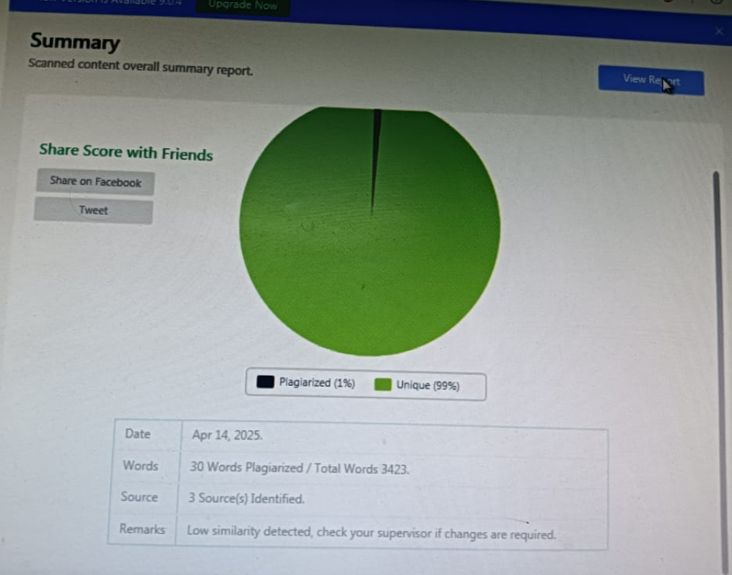

Appendix 5
Information of Project Group Members
Member 1

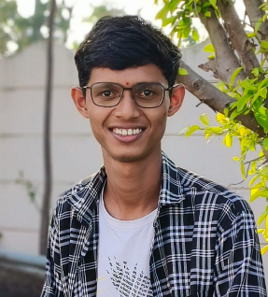
- Name : Satyakam Gajanan Mangate
- Date of Birth : 06/05/2002
- Gender : Male
- Permanent Address : At Shelgaon Tq. Kannad, Chhatrapati Sambhaji Nagar
- E-Mail : satyakammangate45@gmail.com
- Mobile/Contact No. : 9370973297
- Placement Details : --
- Paper Presented/Published : Yes
Member 2


- Name : Yash Babusha Tarde
- Date of Birth :14/11/2001
- Gender : Male
- Permanent Address : A/p: Wadeghavan Tal: Parner Dist: Ahilyanagar 414302
- E-Mail : yashbtarde14@gmail.com
- Mobile/Contact No. : 9022674798
- Placement Details : --
- Paper Presented/Published : Yes

